Study Group | STeLLA Study Group 1 – 29 September 2012
PD Leader (PDL) | Jody
Teachers | Morgan (MA), Colleen (CC), Tami (TB), Stephen (SB), Amy (AB), Khlang (KY)
Context | Study Group 1 is the first after school study group meeting following a ten-day summer institute. During the summer institute, teachers watched video of teachers outside of the group. This is the teachers’ first analysis-of-practice session using video from their own classrooms.

 |  | Line
00:00 | MA | 1 | Um, and so, um, this- all the students said that it’s the tilt of the earth, which is right.
00:08 | MA | 2 | It’s not, you know, the- the- the sunlight is- is hitting. And all the students agreed it was the tilt of the earth.
00:15 | MA | 3 | But then- then we took the globe and we moved the globe like that to see the angle. And it just made me think that that,
00:28 | MA | 4 | um… that’s reinforcing a misconception that the earth’s angle changes literally-
00:33 | CC | 5 | We did talk about that.
00:34 | MA | 6 | ch- literally changes.
00:36 | MA | 7 | And so…yeah.
00:41 | PDL | 8 | sss-So-
00:42 | MA | 9 | But it- but it also- I- I did also put on here that- that it’s- it’s a great lead in to the next lesson on tilt.
00:49 | MA | 10 | Because you- because you’re making visible this idea that, oh, you know, we can just change the tilt of the earth maybe.
00:56 | MA | 11 | So that’s- that’s there. And then we go into our next lesson and we start to talk about…
01:03 | MA | 12 | so…
01:05 | MA | 13 | I don’t know if any of that was clear.
01:07 | CC | 14 | No, I got what you’re saying because I think by-
01:08 | CC | 15 | like when you’re holding the globe, the globe itself was put at the tilt because it’s on like the hole or whatever.
01:13 | MA | 16 | Yeah, mm-hmm.
01:14 | CC | 17 | But it was hard to see the way that that globe was a very intense angle. And so that’s when someone moved it way back,
01:20 | CC | 18 | and it did illustrate the point that, oh, because when it’s at this angle, I can see that the- the light is less intense as the angle curves.
01:29 | CC | 19 | And I think you’re right, that that’s not ideal because they see it moving like this.
01:32 | CC | 20 | But at the same time, you’re right, because the next lesson they’ll see, the tilt is always the same but you will see that angle more.
01:39 | MA | 21 | And in a perfect world, you know, the student would have lifted the flashlight up.
01:42 | CC | 22 | Right, (inaudible).
01:43 | MA | 23 | The- the earth would have stayed the same at the same tilt and the flashlight would have gone up and we’d see the same-
01:49 | CC | 24 | Right.
01:51 | MA | 25 | s- s- light’s coming from the same place.
01:52 | PDL | 26 | Do you remember how we did that in the summer?
01:53 | MA | 27 | No, r- r- review that.
01:55 | PDL | 28 | We actually pulled up two flashlights so that we could get- reme- I- do you remember that?
02:01 | CC | 29 | Yeah.  Figure 5: The farther you are away from the equator, sunlight strikes the surface at greater angles, resulting in the Sun’s energy being more spread—less intense—at higher latitudes.  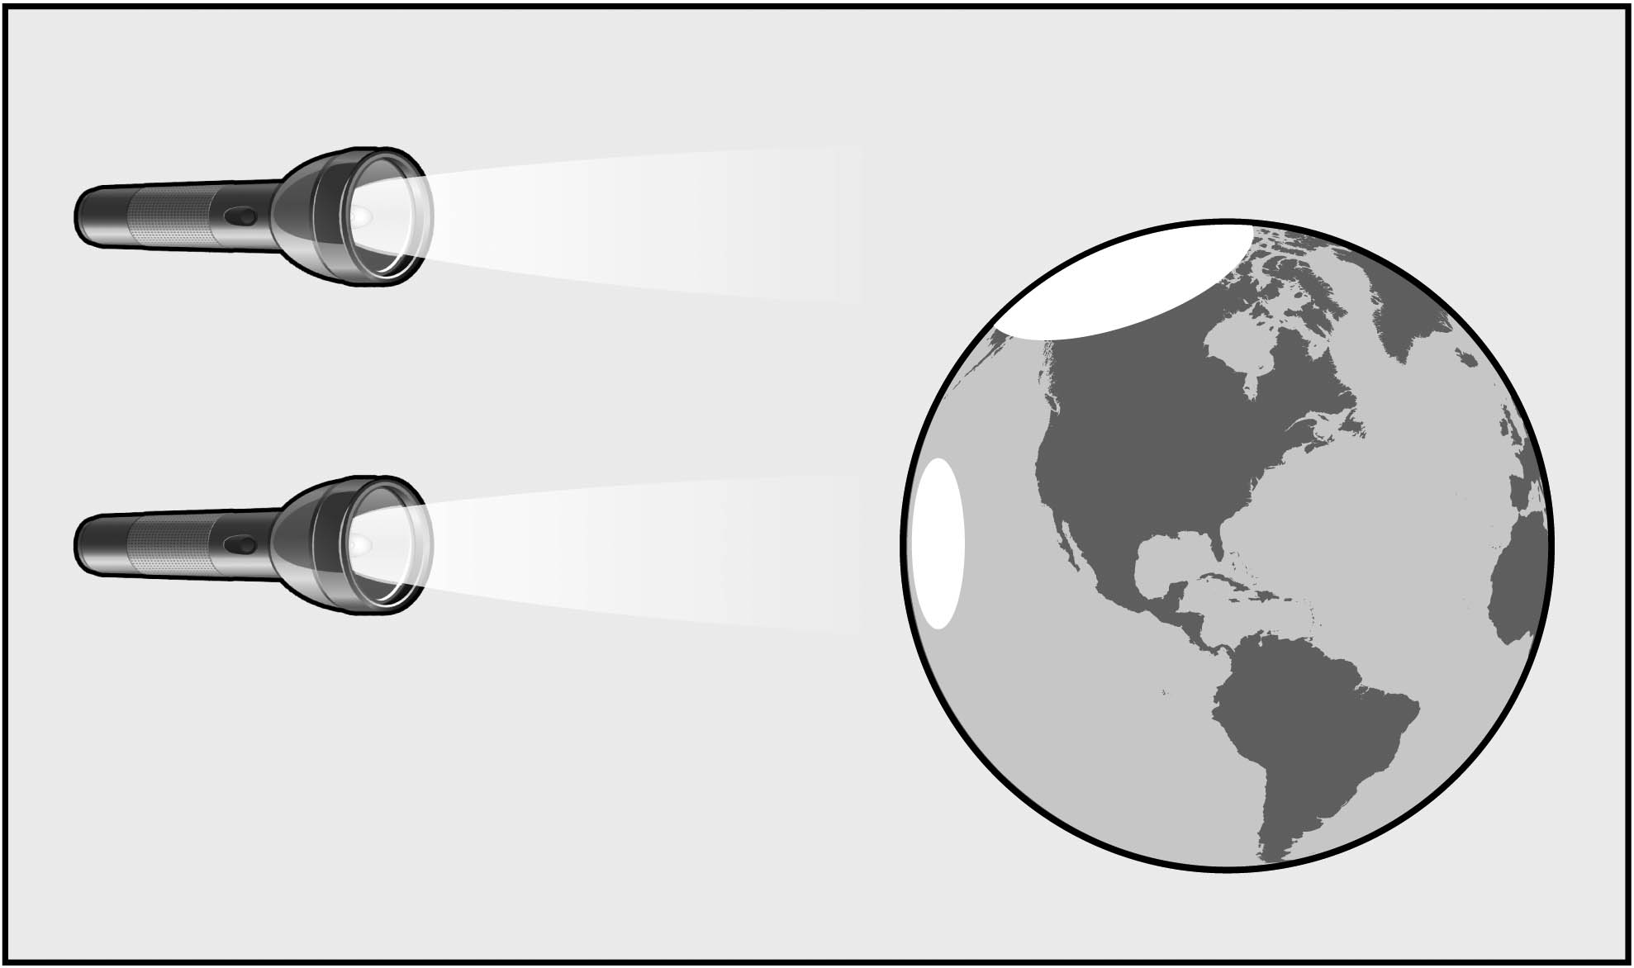
02:01 | MA | 30 | Good idea.
02:03 | PDL | 31 | And if you look in your content-deepening doc…
02:05 | PDL | 32 | when I say content-deepening doc, do you know what  I’m talking about?
02:08 | CC | 33 | No.
02:09 | PDL | 34 | At the back of your lesson plan binder, there’s a- a  document that reviews some of the key science ideas  in this- in these six lessons.
02:19 | KYJ | 35 | Mm-hmm.
02:20 | PDL | 36 | And in that content-deepening document, there’s even  a diagram that uses the two-flashlight approach
02:26 | PDL | 37 | to sort of the whole class conversation about what’s going on.
02:30 | PDL | 38 | Because I want to push back a little bit.
02:34 | PDL | 39 | Is it the tilt? That’s my question to you. Is it the tilt?
02:39 | PDL | 40 | And I want you to read this first idea here that we talked about earlier today.
02:45 | SB | 41 | No.
02:48 | SB | 42 | It’s not the tilt.
02:52 | PDL | 43 | So, Stephen, you’re claiming it’s not the tilt. So what is it if it’s not the tilt?
02:56 | SB | 44 | Ss- the spherical shape of the earth. It’s the spherical shape and the way the angle of light hitting that’s-
03:06 | SB | 45 | that curved surface of the earth disperses the light and makes it more oval.
03:17 | PDL | 46 | So who can paraphrase what Stephen just said? Can you put that in your own words?
03:24 | TB | 47 | The curvature of the surface of the earth…is…
03:32 | TB | 48 | what determines how intense the rays…are that are hitting different parts.
03:40 | PDL | 49 | And can you give us an example of the different- like an example of the different parts, what you mean by different parts?  Figure 3: Light striking a surface “straight on” is more concentrated—or intense—than light striking a surface at an angle.  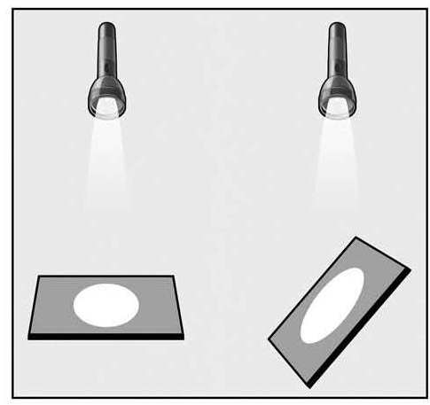
03:49 | TB | 50 | Um…well, you got this curvature of the earth but…the-  oh boy, the sun’s rays are going to hit more directly…
04:01 | TB | 51 | on…oh man, this is going to be hard.
04:06 | SB | 52 | On the equator.
04:07 | TB | 53 | Uh, at the equator and then- and like you said,  that disperses it then above and below the equator.
04:16 | TB | 54 | And I think it was kind of hard for the kids to see that  because they’re using a flat surface…
04:24 | KY | 55 | Mm-hmm.
04:25 | TB | 56 | you know, the book or the tray or whatever that’s a flat  surface.  Figure 4: Modeling angles of sunlight on Earth’s surface  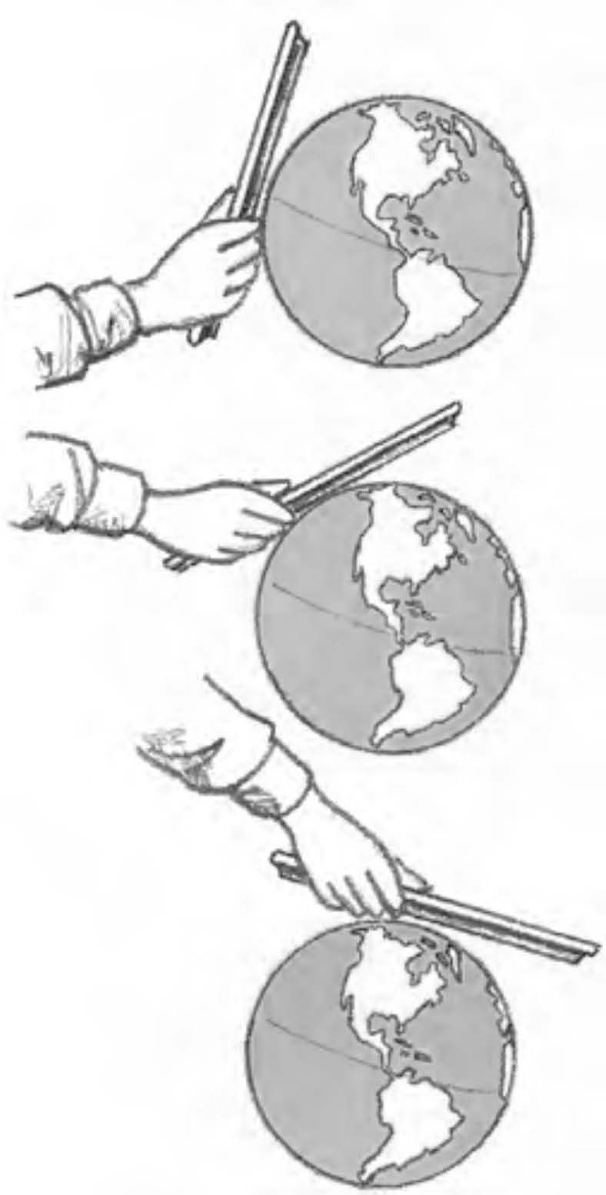
04:29 | TB | 57 | Whereas, the earth is actually curved, so it’s harder to  s- for them to make that connection between the dispersement.
04:38 | PDL | 58 | So dig into Lesson Plan 2 and look at the handouts that students  have to use. There. You’ve got it there, right, Amy?
04:46 | AB | 59 | Yep.
04:47 | PDL | 60 | Can you hold up the- the r- content representation that you were  looking for?
04:51 | AB | 61 | There’s another one that I don’t think is in here.
04:53 | SB | 62 | It’s where they hold their clipboard to a- a ball and they move it  around the ball.
04:59 | AB | 63 | There’s another one, though, that we saw.
05:01 | PDL | 64 | Is there another one?
05:02 | AB | 65 | There’s one that has the earth like this and then a lot of- several lines kind of at different angles.
05:06 | MA | 66 | I remember that one.
05:08 | CC | 67 | Mm-hmm.
05:09 | AB | 68 | And so that helped make the link between the tray and what are we talking about when we’re talking about angle.
05:14 | MA | 69 | And no emphasis on tilt on that.
05:17 | AB | 70 | Right.
05:18 | MA | 71 | It’s all-
05:19 | AB | 72 | So, yes, the earth is perpendicular like this and then you can see- that one.
05:25 | PDL | 73 | That’s the one, ding, ding, ding. So it’s that one, and I- I think that one’s helpful, too, for a little bit different reason, and it’s-  Figure 2: The Sun’s Incoming Energy – Angle Related to Latitude  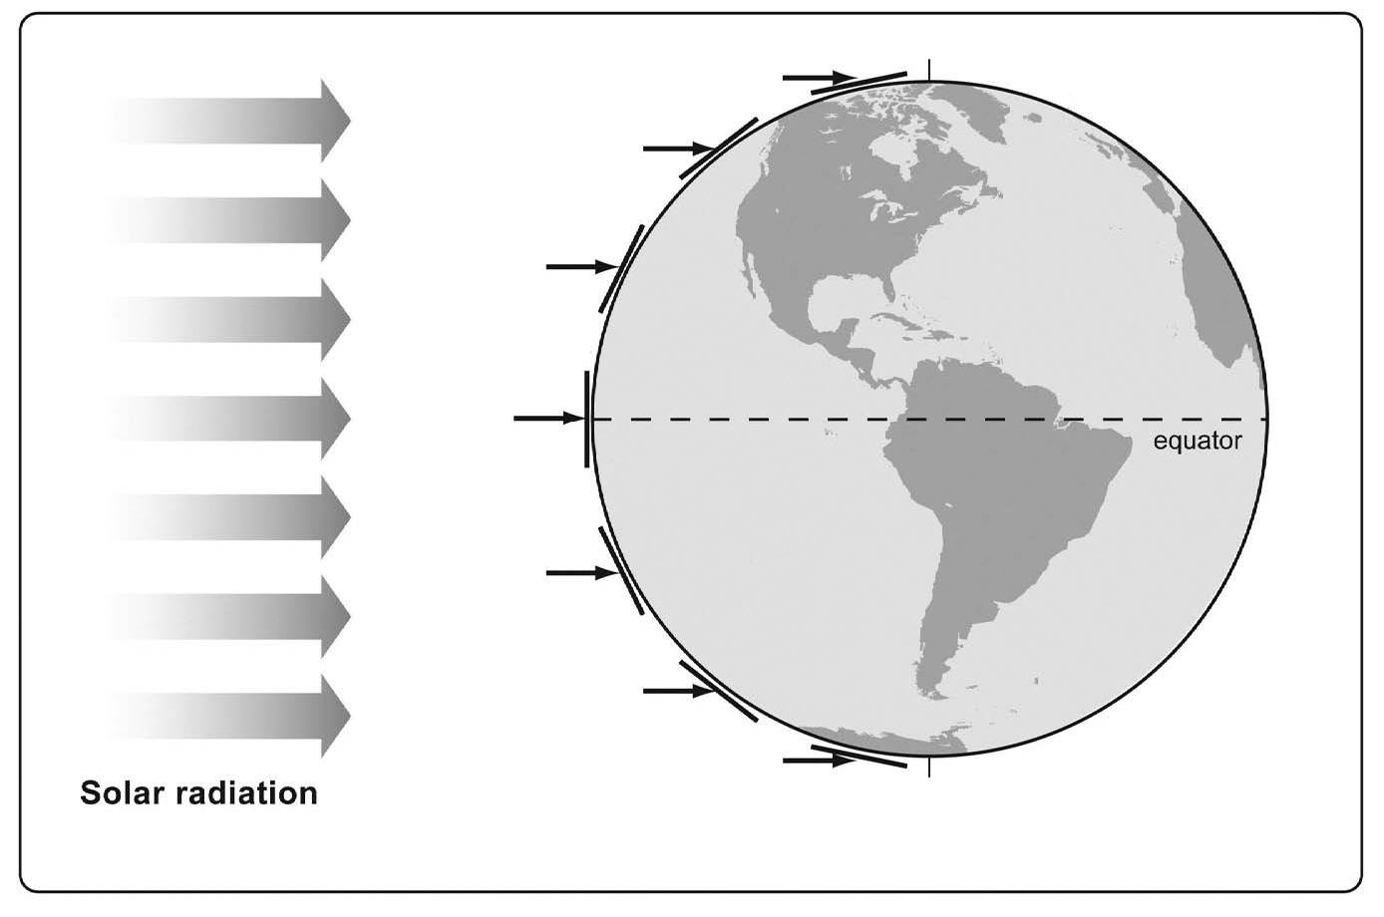
05:33 | MA | 74 | Mm-hmm.
05:33 | PDL | 75 | to me, that one is the one that’s most  con- concrete. Yeah, there you go.
05:41 | PDL | 76 | So is it the tilt?
05:51 | PDL | 77 | No.
05:53 | SB | 78 | It’s the curvature.
05:55 | PDL | 79 | It’s the curvature of the earth.
06:00 | PDL | 80 | Are we okay on that?
06:02 | MA | 81 | Mm-hmm.
06:03 | CC | 82 | I guess I associate as both, though. Because when it’s tilted, the curvature is increasing in a way.
06:09 | CC | 83 | I mean it- it’s not, but like the angle is different because of the tilt.
06:13 | CC | 84 | So, yeah, it also has a curvature but then if you tilt it, isn’t the angle even more?

