Clip name | Engage students in developing and using models
Grade/Content | 5th Grade / Sun’s Effect on Climate and Seasons
Unit Focus | Why are some places on Earth hotter than others at different times of the year?
Lesson Main Learning Goal | Earth’s consistent tilt produces opposite seasons in the Northern and Southern Hemispheres.
Context | In previous lessons, students used data to explain that, in general, it is warmer closer to the equator and colder toward the poles They conclude that as sunlight hit’s Earth’s curved surface, it strikes at different angles. When light strikes “straight on” it is more intense than when light strikes “at an angle” because the light striking at an angle spreads over a greater surface area.  In this lesson, student use a new model – one that shows Earth in its orbit around the Sun  – to figure out how the idea of light’s intensity at different latitudes might change as Earth orbits the Sun.  Lesson Focus Question: Why is it summer in the United States (Northern Hemisphere) when it is winter in Argentina (Southern Hemisphere)?  Lesson Activity: Students explore a model of Earth as it orbits the Sun.  Video Clip: In these two clips, students are working with a model to understand why it is summer in North America when it is Winter in South America. Students have been trying to figure out if their initial ideas about the movement of the Earth in relation to the sun will explain seasonal patterns and realize that they are missing a key element of the model  – the Earth’s consistent tilt toward the North Star.
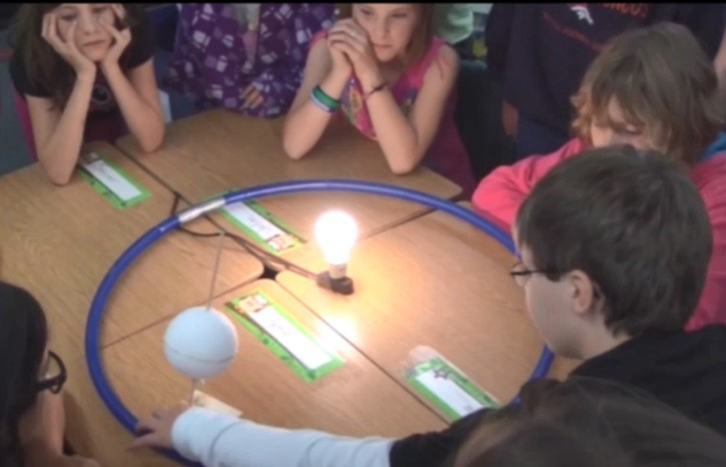
KEY: T: Teacher
SN: New student talking
S: same student continues talking
SS: multiple students talking

Clip 1 |  | Line | Working with a small group
00:01 | SN | 1 | Okay.
00:01 | SN | 2 | So-
00:02 | SN | 3 | Stop it- stop it.
00:03 | SN | 4 | So, because it's fur-
00:05 | SN | 5 | So again, it's not pointing at the sun straight, basically. That's- that one's pointing straight at the sun.

00:11 | SN | 6 | The sun's light is a bit- going a bit more higher up here and this is farther away because of the axis.
00:15 | SN | 7 | So it's spread out and there's more surface area.
00:19 | T | 8 | Micah, can you tell me- can you tell me what you mean by “farther away”?
00:24 | SN | 9 | Down here, it's sort of down- the light isn't as- there's more surface area where light is less intense, but up here the light's more straight on than down in South America.
00:38 | T | 10 | So is it that it's farther away or that it's, like you said-
00:42 | S | 11 | It's at a tilt.
00:42 | T | 12 | more-
00:43 | S | 13 | It's more surface area.
00:45 | T | 14 | More surface area, what does that mean?
00:46 | S | 15 | Like when it tilts.
00:47 | SN | 16 | It's more direct.
00:47 | SN | 17 | When it's tilted, there's more surface area, so the light spreads out and gets less intense.
00:52 | T | 18 | So it's covered-
00:52 | SN | 19 | And it- it does- it's not straight aiming at it like this one. This is basically straight.
00:56 | T | 20 | So Maya, what are you pointing to?
00:58 | S | 21 | The- North America.
00:58 | SN | 22 | Straight onto the orange right here.
01:01 | T | 23 | What does the orange represent?
01:02 | SS | 24 | North America.
01:03 | T | 25 | North America.
01:04 | SN | 26 | It's pointing straight at it, basically, and this one's going down, so the sun's slipping down.
01:09 | SN | 27 | I would say that it's not the sun's-
01:10 | T | 28 | Yeah, okay.
01:11 | SN | 29 | This is getting a- a lot of light here.
01:14 | SN | 30 | So, getting a lot more intense light.
01:15 | SN | 31 | Yeah.
01:16 | SN | 32 | It's getting a lot more intense light, and here, it's- it's just kind of sliding off.
01:21 | SN | 33 | It’s- the light’s more dimmer or spread out.
01:22 | T | 34 | You guys are having a very good conversation about some stuff that we've talked about. Remember our focus.
01:28 | T | 35 | Make sure you can show me in about four- three or four minutes summer in North America, summer in South America. Show me on your rotation- I'm sorry, your revolution around the sun.

01:40 | T | 36 | Show me where it would be summer in No- North America, summer in South America,  okay?
01:44 | SN | 37 | Okay, then, so…
Clip 2 |  |  | Students gather in whole group to discuss their ideas:
01:49 | T | 38 | On that idea, can you go ahead and show me? 'Cause you're talking about tilt now. Can you show me with the revolution of the earth around the sun, can you show me how that would work?
01:57 | SN | 39 | Sure. So right here, it's facing down, so North America's getting the heat, but over here- over here, it's facing-
02:15 | S | 40 | well, it's still- it's facing up a bit more as it goes around the- when this- because of the tilt, sometimes it's- it's facing down and sometimes it's facing up.
02:32 | T | 41 | Okay, what times would it be facing down and what times would it be facing up?
02:35 | SN | 42 | This is fall.
02:36 | SN | 43 | For us-
02:37 | T | 44 | And I- and we're still talking about South America or North America?
02:41 | SN | 45 | A little bit of both, 'cause right here South America is getting a lot of light, but, like, over there, near the tape spot, it's tilted sort of inward so North America's getting (a bit more?).
02:57 | T | 46 | So- okay, show that one more time to the group. So- right there, Sou- North America's getting a lot of light, and where was South America getting a lot of light?
03:04 | S | 47 | Over here, at the opposite side.
03:07 | T | 48 | Okay, so right there in that position, that right there is different, so right here South America's getting more light?
03:15 | S | 49 | Yes.
03:17 | T | 50 | As opposed to…
03:18 | SN | 51 | Over there near the-
03:19 | T | 52 | Over here-
03:20 | O | 53 | RW
03:30 | T | 54 | So over here, North America's getting more light?
03:33 | SN | 55 | Yeah.
03:34 | T | 56 | Does anybody agree or disagree with that?
03:36 | T | 57 | What do we think? Sebastian, what do you think?
03:38 | SN | 58 | What he's saying is, like, as you tilt it, the axis is still on, like, touching the orbit in the model, but then the earth is still moving at the same time, it's still spinning around.
03:50 | S | 59 | So if you spun it around, it would- it would be saying what he said.
03:58 | T | 60 | If you spun it around. So if- if you spun this around?

04:01 | S | 61 | Yeah.
04:01 | T | 62 | So if I- so here, if I spun that around-
04:06 | S | 63 | While it was still in orbit, it would-
04:09 | T | 64 | Okay, so what side is getting more direct light, North- Northern Hemisphere or Southern Hemisphere, when I spin it around?
04:15 | S | 65 | Northern.
04:15 | T | 66 | Okay. So if I move it back to the original position, what side is getting more direct light, the Northern or the Southern?
04:25 | T | 67 | What do you guys think over here? You can see that pretty well. Emma?
04:27 | SN | 68 | Northern.
04:28 | T | 69 | Northern Hemisphere still is. So it seems like on this side and on this side, Northern Hemisphere's getting more direct light.
04:33 | T | 70 | I think we need to add some information to our model. Do you guys agree?
04:36 | SS | 71 | Yes.
04:37 | T | 72 | Let's add…

